Seoul Youth Forum on the Urban SDGs:
“Engaging Youth, Sustainable Cities, Better Future”

❖ PARTICIPANT APPLICATION FORM ❖
*This form should not be modified.*

Please submit this application form to sdgyouth@mizy.net by 23:59, September 22nd (Thu).
All information and answers should be written in English.

1. Personal Information
Name | (Given) (Family) | Nationality
Gender | □ Ms. □ Mr. □ Mx. | Date of Birth | YY / MM / DD
School/Affiliation
Major/Field
Address
Email
Mobile Phone
2. Self-Introduction & Motivation to Apply
1) Please give us a brief introduction of yourself. - less than 200 words.
2) What is your motivation to apply for this program? - less than 200 words.
3. Your Idea about the Forum’s Topic – SDGs & Urban SDGs
1) Which goal, among the 17 Sustainable Development Goals, are you most interested in? Why do you think it is important? – less than 300 words.
2) What is the most urgent problem or issue of your city/town/community that needs to be addressed? And why is that? – less than 300 words.
e.g. #housing (housing prices, increasing slums) #urban services (waste management, sanitation, water) #inclusive public spaces #disaster management #civic participation, etc. – Any problem/issue can be discussed.
4. Others
Any other comment to strengthen your application?
MIZY Center offers accommodation and meals throughout the forum.
(All participants are required to stay at the hostel for 4 days 3 nights.)
Please tell us your special dietary or medical needs if you have any.

I, , hereby certify that
the information given above is accurate.

Date: 2016 / 09 / DD Name: (Signature)

CONSENT FORM FOR PROCESSING THE PERSONAL INFORMATION

To comply with the Article 15, Article 17, and Article 24 of 「Personal Information Protection Act」, Seoul Youth Center for Cultural Exchange(MIZY Center) must have your consent about processing (collection, use, transfer, etc.) your personal information as below.

■ Consent to the Collection and Use of the Personal Information
Purposes of Collection and Use | Reviewing qualification, supporting after selection, following-up management, etc.
Collected Items | All information filled in an application including name, mailing address, phone number, email address
Period of Retention and Use | Until the purposes of collection and use of personal information are attained from the day of agreement
Company of Collection and Use / Program Name | Seoul Youth Center for Cultural Exchange(MIZY) / Seoul Youth Forum
Rights to Refuse and Disadvantages for refusal | You have the right to refuse the collection and use of your personal information as above.  ※However, if you refuse the collection and use of your personal information, your application could be cancelled

■ Consent to the Processing of Personally Identifiable Information
Personally Identifiable Information | Name, date of birth, contact number, mailing address, e-mail address, affiliation.
Purposes of Collection and Use | Reviewing qualification, supporting after selection, following-up management, etc.
Period of Retention and Use | Until the purposes of collection and use of personal information are attained from the day of agreement  ※Completely destruction(impossible to restore) at the termination of retention period.
Rights to Refuse and Disadvantages for refusal | You have the right to refuse the collection and use of your personal information as above.  ※However, if you refuse the collection and use of your personal identifiable information, your application could be cancelled

I hereby have carefully read and sufficiently understood the explanation on
「Processing Personal Information and Personal Identifiable Information」and agree with the information in this sheet.

□ I Agree □ I Do Not Agree
※ Minors under 19 necessarily need an agreement of guardian(legal representative).
2016. . .
Participant Name: (signature)
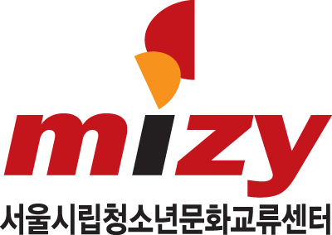 Seoul Youth Center for Cultural Exchange

